

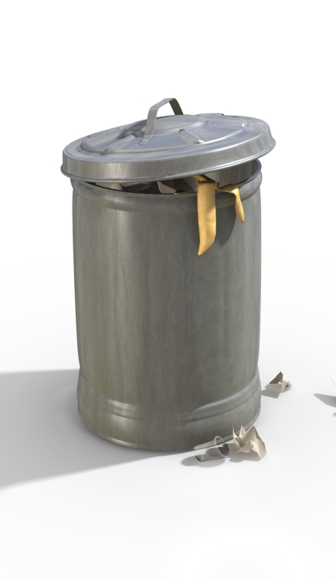
Due to CHRISTMAS AND NEW YEAR HOLIDAY
GARBAGE will be picked up
EARLY morning Wednesday 12/24/25
12/31/25
Please put your garbage out the night before.

